45 Minutes
I had some struggles asigning items to a list in a function. Otherwise the program went smoothly!

‘y’, ‘yes’, ‘n’, and ‘no’ are all valid responses to finish the program
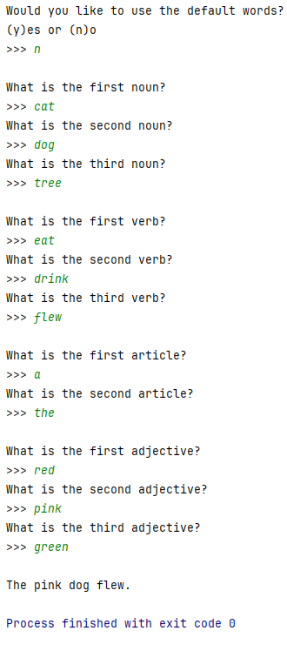
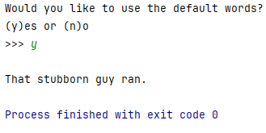
Output:

